
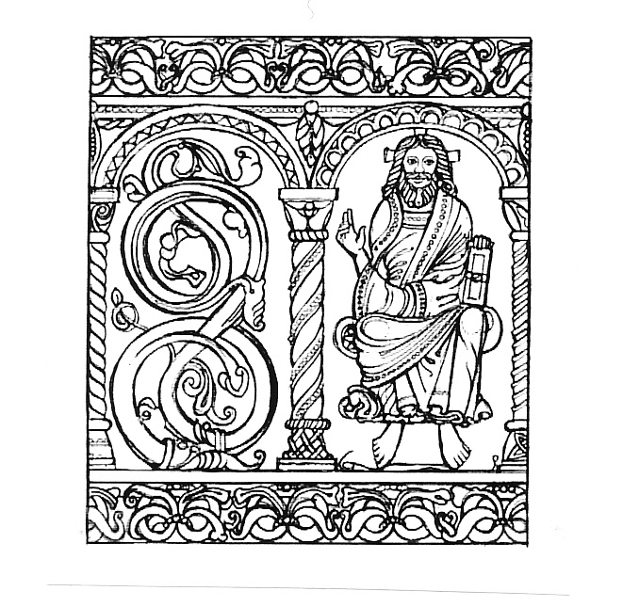
GLHA Summer Afternoon
Saturday 20th June 2026

We are very pleased to invite you to spend an afternoon in our beautiful parish.
Meet at the Church of St Mary & St Peter, Tidenham Village, NP16 7JQ,
just off the A48 east of Chepstow (full directions with booking)

1.30pm Doors open. Tea / coffee / cold drinks available. Local history display.

2.00pm Welcome by Sally Self, Chair of GLHA.
An introduction to Tidenham Parish by Richard Clammer, Chair of Tidenham Historical Group.

2.30pm Group activities (see below).

4.00 – 5.00pm Tea to include cakes and scones, tea, coffee, and cold drinks.

5.00pm End of afternoon

Group activities:

Option 1. A detailed guided tour of Tidenham Church and churchyard, exploring its long and fascinating history, architectural details and discussing the story of many of the significant people buried in the churchyard. The only walking involved will be around the church interior and the churchyard. The latter can be tailored to individual needs.

Option 2. A walk from the church to the route of the former Chepstow to Monmouth Wye Valley Railway (now the Wye Valley Greenway) viewing Tidenham Tunnel, the site of Tidenham Halt and other historical features and passing the modern Tidenham Manor. The walk is on footpaths involves only a few gentle slopes and a flight of steps. Distance 1.5 miles, relatively easy going.

Option 3. A walk through Tutshill village to view the medieval watch tower and two significant houses, Penmoyle and Eastcliffe. The latter was built in 1925 and permission has been granted by the owners to go into the garden and walk along a spectacular cliff top path with dramatic views of the River Wye below. A five-minute drive from the church in shared cars and then a relatively easy,1.5 mile walk with only one short, uphill section.

Option 4. A visit to the former Beachley to Aust ferry “Severn Princess” which is undergoing restoration as a static exhibit in Chepstow. The Old Passage ferry was the only vehicle-carrying crossing of the Bristol Channel below Gloucester until 1966 when the Severn Bridge was opened and the vessels withdrawn. “Severn Princess” became a workboat on the west coast of Ireland until discovered in a derelict state and brought home. Tim Ryan, who has led the project, will explain her history and the restoration project. A ten-minute drive from the church. Steps with handrail up to the deck of the vessel. No walking involved.

Cost £10 per person to include afternoon tea.

Booking arrangements.

To book a place - please complete the attached booking form and email / post with the appropriate payment to:

Carol Clammer, The Secretary, Tidenham Historical Group, 2 Westbourne Villas, Sedbury Lane, Tutshill, Nr Chepstow, NP16 7DZ . carolclammer@googlemail.com Tel: 07712574471

Completed forms must be received by 30th May 2026.

This event has been organised in partnership with The Friends of St. Mary & St.
Peter, Tidenham, who have provided the refreshments and much practical support. We are
extremely grateful to them. Any donations to the continued upkeep of the church will be
appreciated

General enquiries about Tidenham Historical Group the group to: tidenhamhistoricalgroup@gmail.com


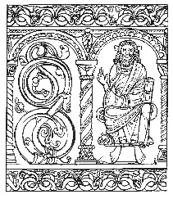
Gloucestershire Local History Association
Summer Afternoon – Saturday 20th June 2026
Booking Form
Enquiries about the event and walks to: Carol Clammer: carolclammer@googlemail.com
tel. 07712574471

To book place(s), please complete this form and email to: Carol Clammer: carolclammer@googlemail.com

Please pay by bank transfer, using your name as the reference.
Account name: Tidenham Historical Group
Bank sort-code: 30-91-89
Account number: 00528970
Or post the completed form, with a cheque payable to ‘Tidenham Historical Group’, to
Carol Clammer:
Tidenham Historical Group,
2, Westbourne Villas, Sedbury Lane, Tutshill, Chepstow, NP16 7DZ

Completed forms must be received by Saturday 30th May 2026.

We will acknowledge your booking by email (or telephone where necessary) and confirm detailed directions to the venue and parking arrangements.

Name of your History Group:
Name of Person Ordering:
Email Address:
Telephone:

Every effort will be made to give visitors their first option, however, if demand is high, it will be necessary to allocate on a first come, first served basis.

Visitor’s Name(s) | 1st Choice (Option No.) | 2nd Choice (Option No.)

Cost £10 per person, to include Afternoon Tea

I have transferred £ to Tidenham Historical Group bank account OR
I enclose a cheque for £ payable to Tidenham Historical Group
Special Dietary Requirements (please note any here):

